Lab 2b: Build an Agent with watsonx.ai and crew

In this lab, you will build a Sales Analyzer Agent using Watsonx.ai and Crew AI. This agent will allow you to analyze historical sales data of products for procurement.

Note : Files used in lab can be downloaded from folder “Lab 2b”.

Steps to Create the Agent

Step 1: Create a Project
- If this is your first time using this account, you should create a project before using Agent Lab. You ca use your existing project also.

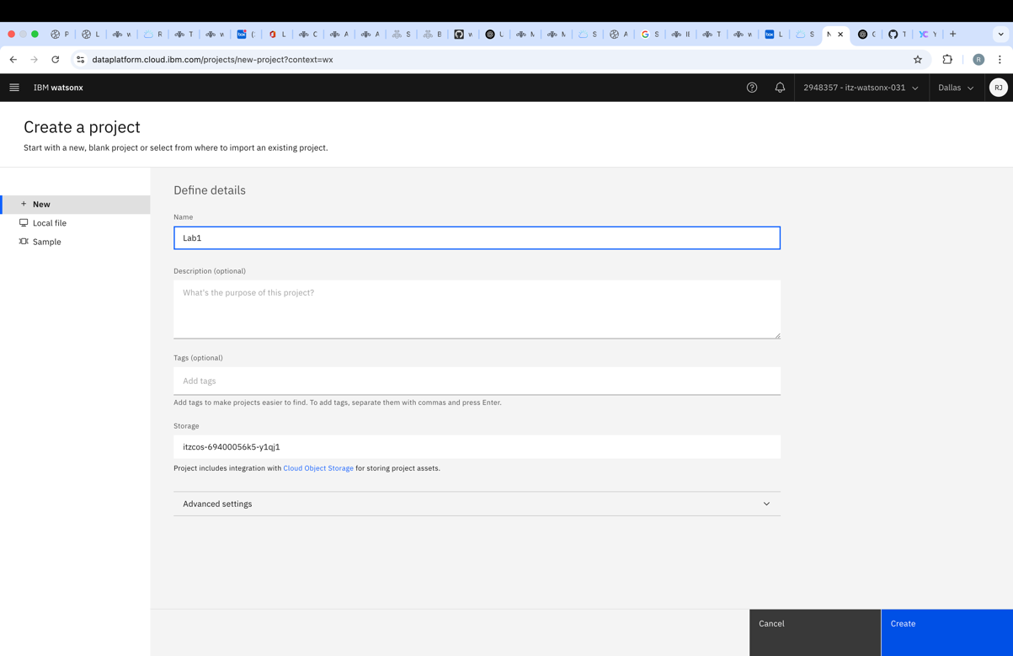

Step 2: Associate the Watsonx.ai Service (No need to repeat this step, if you already did previously)
- After creating the project, navigate to Manage → Services & Integrations → Associate Service.
- Select Watsonx.ai and associate it with your project.

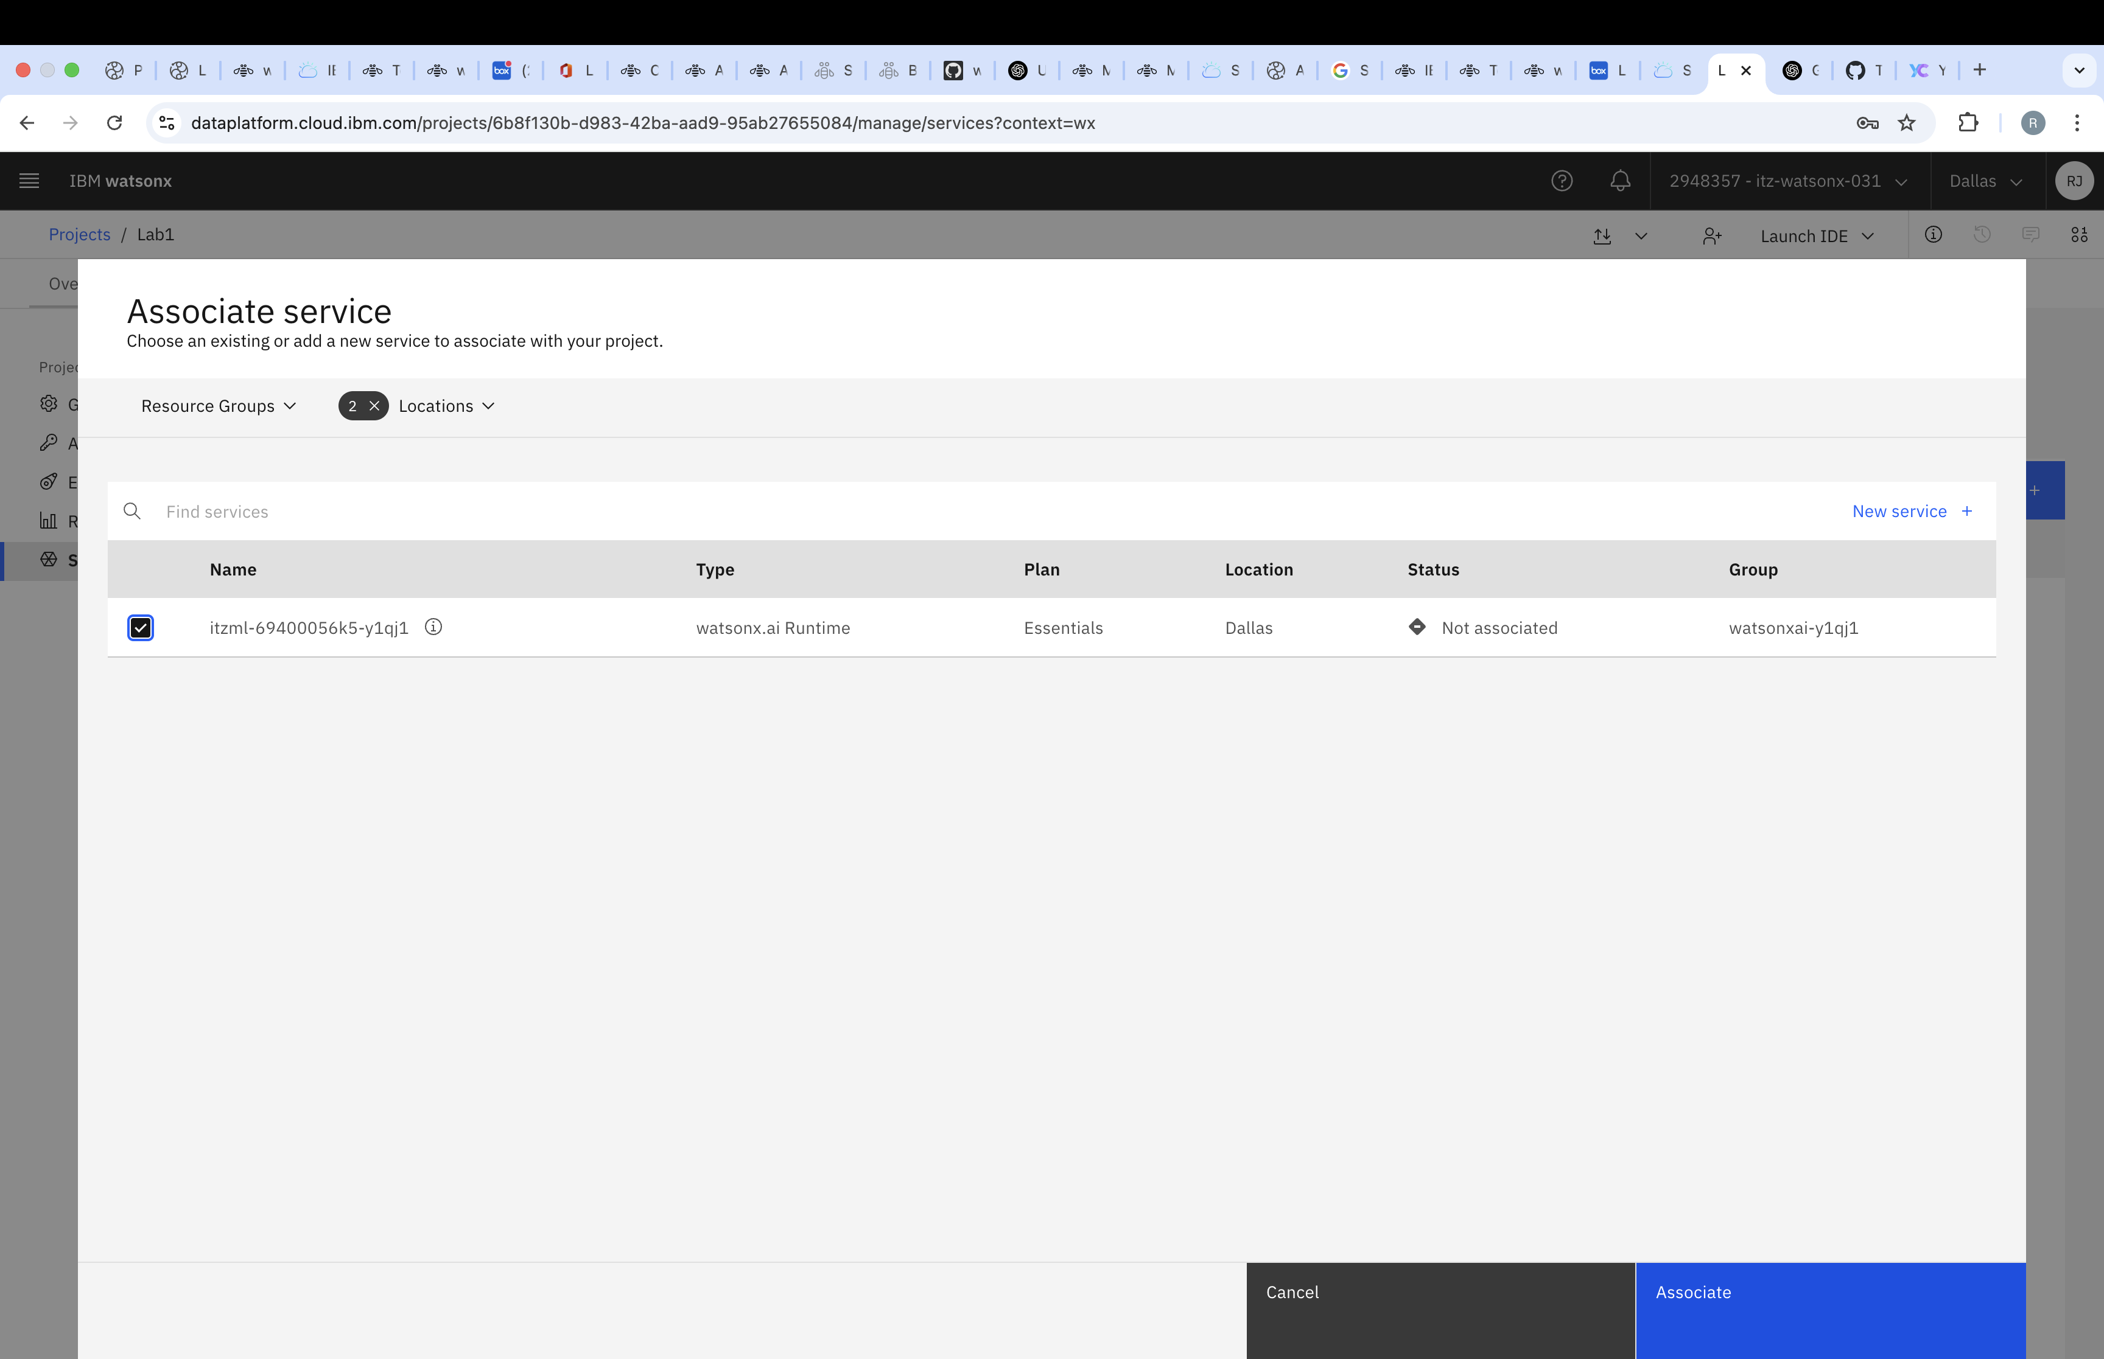

Step 3: Add a New Asset
- Go to the Assets tab and click New Asset.

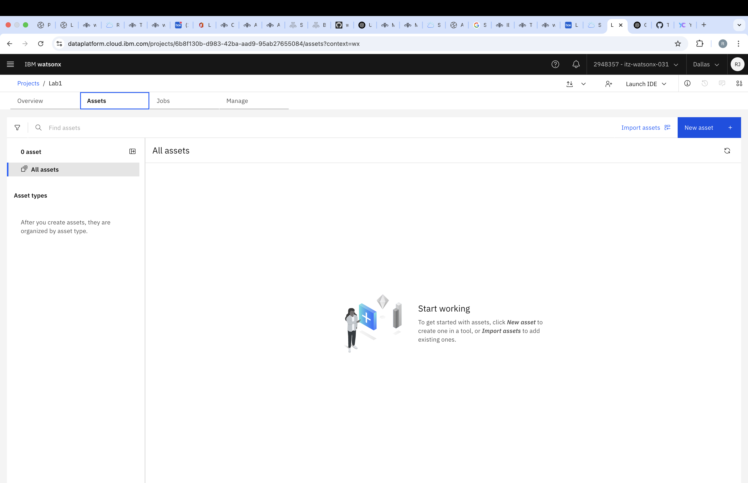

Step 4: Create the notebooks
- Search for "Work with data and models in Python or R notebooks" and click to create a notebook.

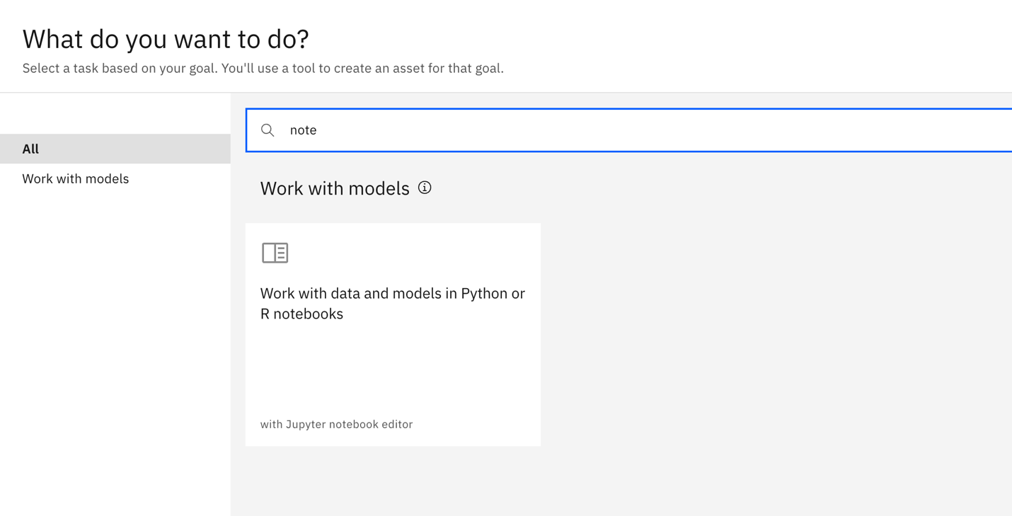

Step 5: Upload the files
- Click on Local File.
- Upload notebook for vector index creation using the Browse option.
  - SalesAnalysis.ipynb
  - SalesAnalysis_query.ipynb
- Click on Create to create the notebook.
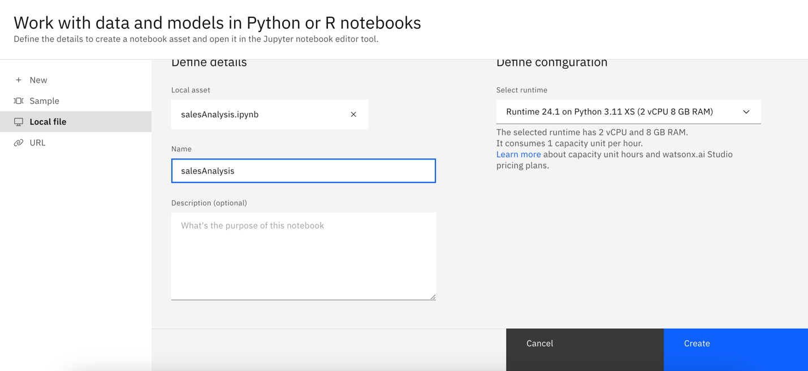
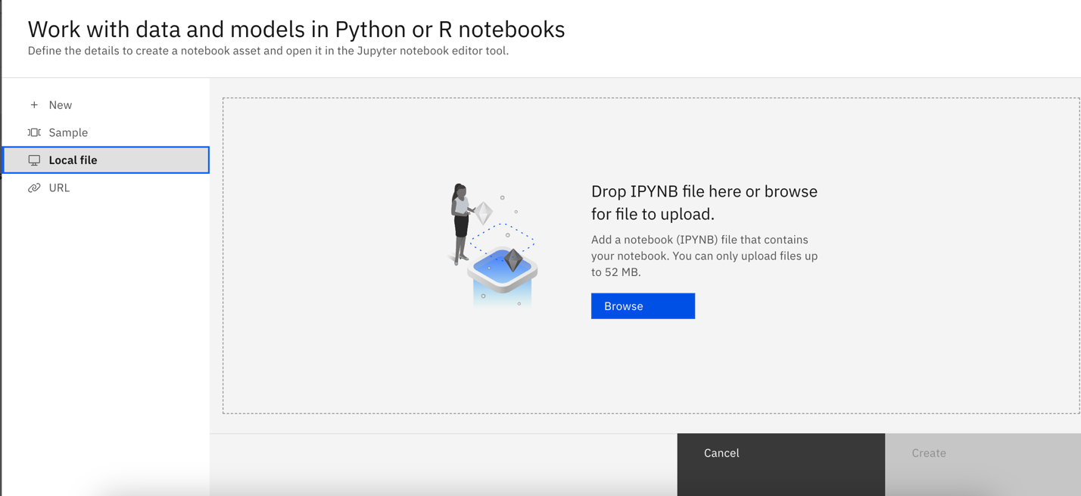

Step 6: Configure the notebook
- Key in the required info to run the notebook
- Create an IBM Cloud API key or get it from the team and update the api_key to initialize the llm. Also verify the api_base value is as per your watsonx instance.
- DB_PASSWORD can be found in “DB Connection Details.boxnote” in the Lab 2b folder

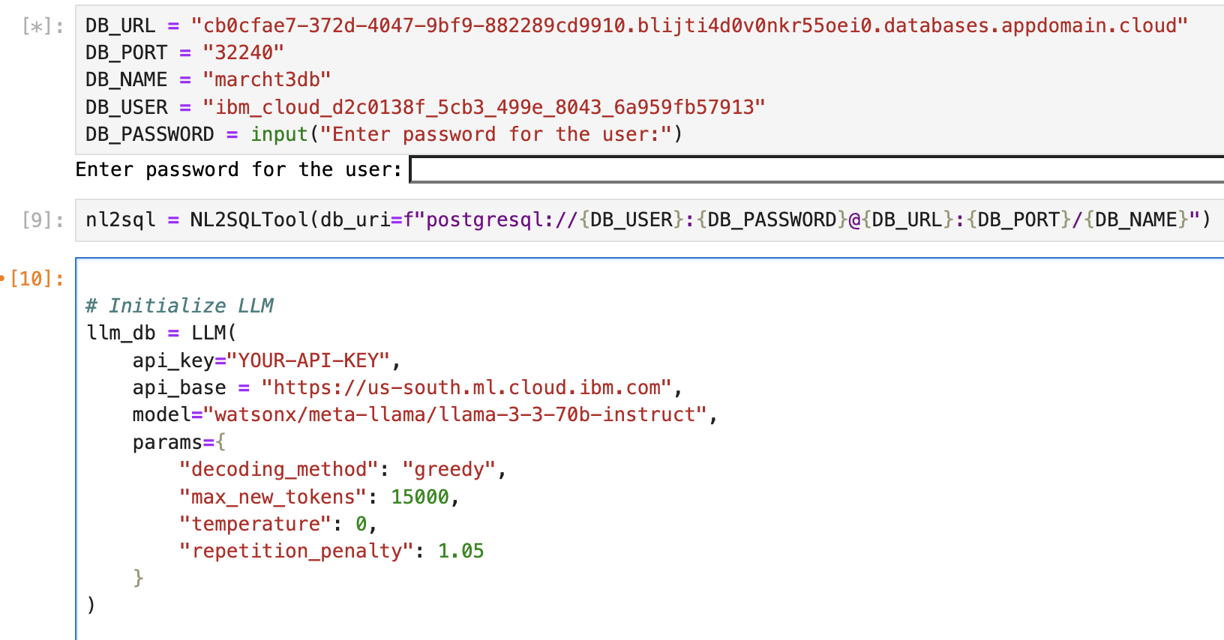

- You can create an API key on the homepage. You can save the api_key in a file on your local machine for future use.

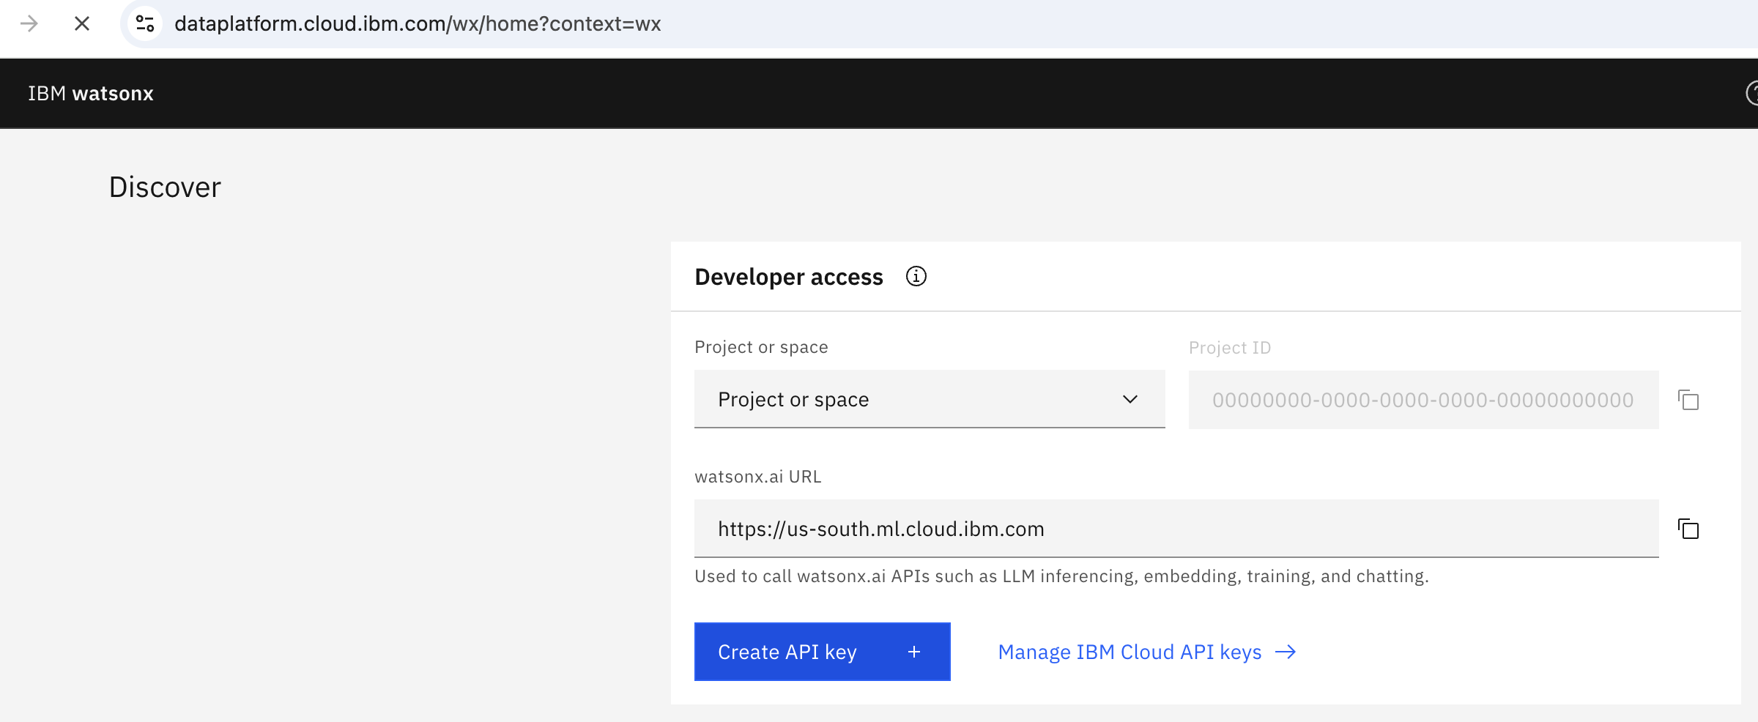

Step 7: Run the notebook

- Follow the cells of the notebook to create and run your sales analyzer agent. Some sample queries are already put as comment to test the outcome.

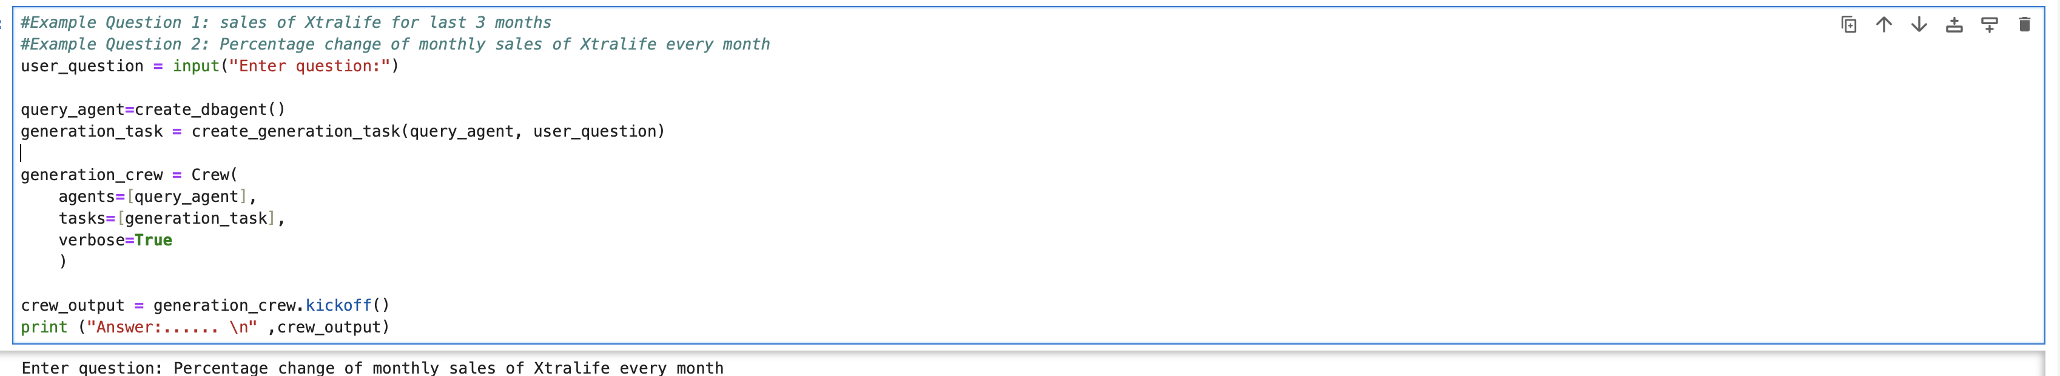
🚀 Congratulations! You have successfully created an AI-powered Sales analyzer Agent powered by watsonx.ai and crew.ai. Happy Coding! 🎯

